# **Software Engineering Assignment**

**MODULE: 4 SE – OOP Concept**

**WAP to print “Hello World” using C++**

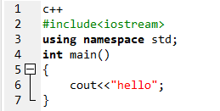

**What is OOP? List OOP concepts**

OOP stands for Object oriented programming. The 4 concepts of OOP are:

1. Encapsulation
2. Abstraction
3. Inheritance
4. Polymorphism

**What is the difference between OOP and POP?**

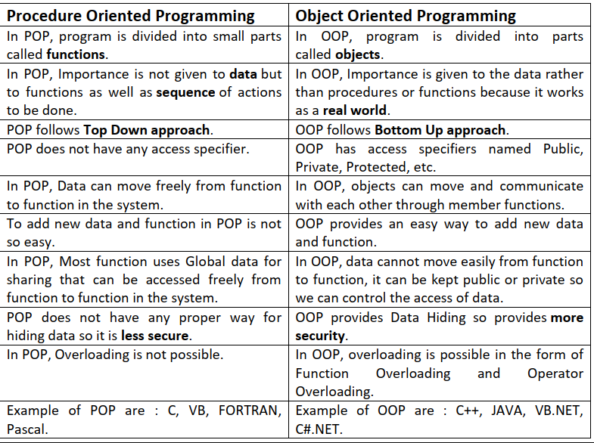

**WAP to create simple calculator using class**

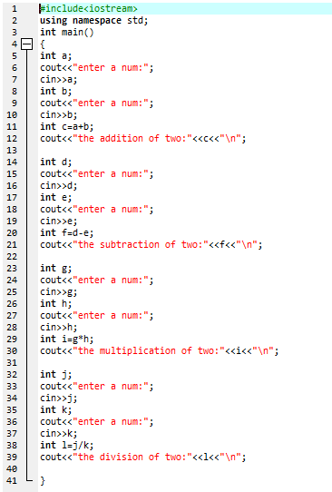

**Define a class to represent a bank account. Include the following members: 1. Data Member: -Name of the depositor -Account Number -Type of Account -Balance amount in the account 2. Member Functions -To assign values -To deposited an amount -To withdraw an amount after checking balance -To display name and balance**

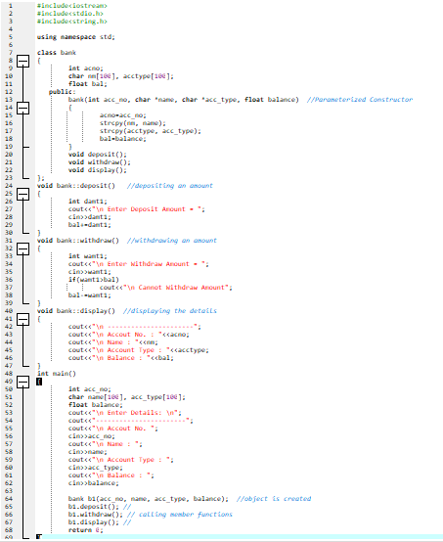

**OUTPUT:  
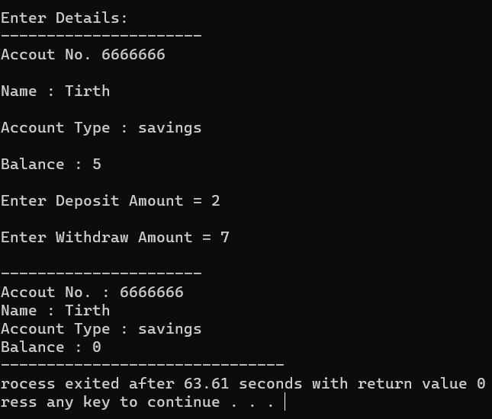**

**Write a program of Addition, Subtraction, Division, Multiplication using constructor.**

**OR**

**Write a program to Mathematic operation like Addition, Subtraction, Multiplication, Division Of two number using different parameters and Function Overloading**

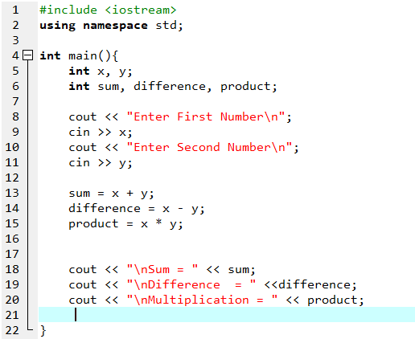

**OUTPUT:  
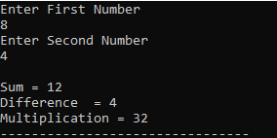**

**Write a Program of Two 1D Matrix Addition using Operator Overloading**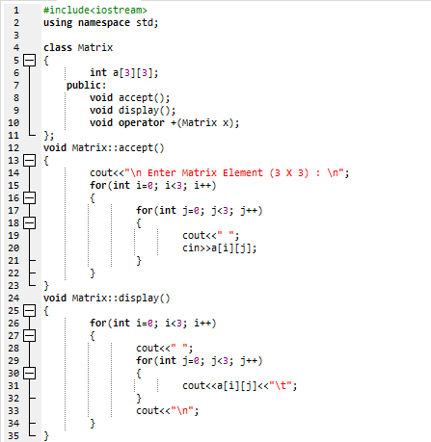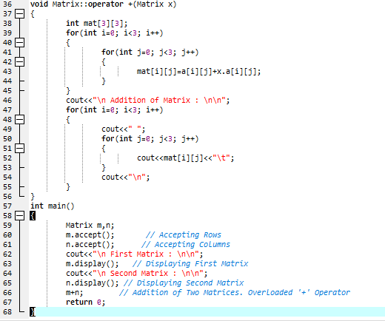

**OUTPUT:  
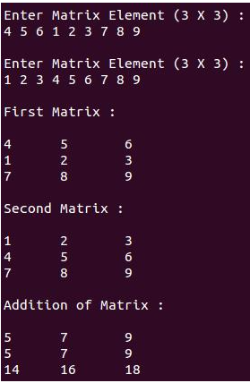**

**Write a program to concatenate the two strings using Operator Overloading**

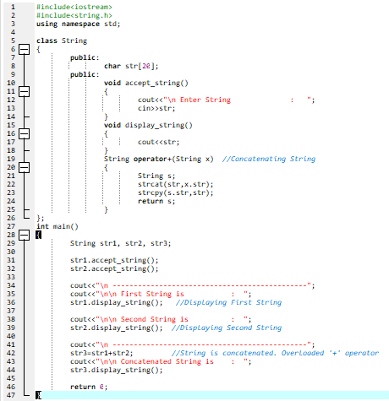

**OUTPUT:  
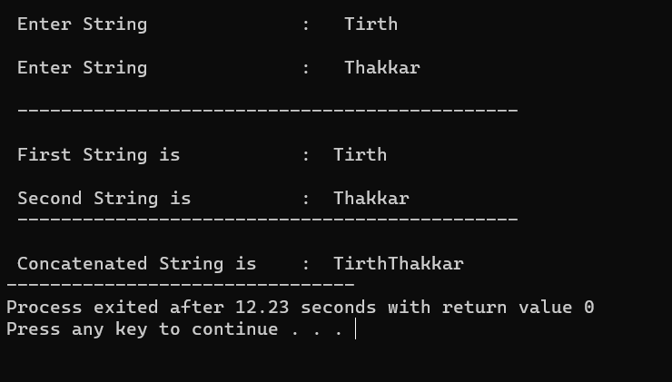**

**Write a program to calculate the area of circle, rectangle and triangle using Function Overloading**

**Circle: Pi * Area *Area**

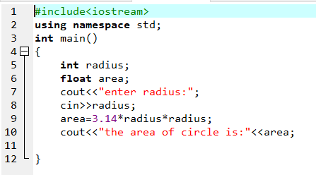

**OUTPUT:**



**Triangle: ½ *Area* breadth**

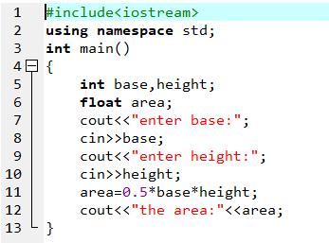

**OUTPUT:  
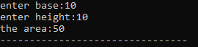**

**Rectangle: Area * breadth**

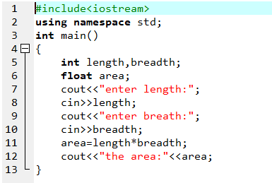

**OUTPUT:  
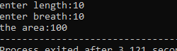**

**Write a program to swap the two numbers using friend function without using third variable**

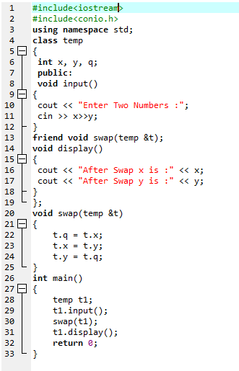

**Output:  
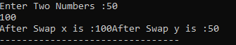**

**Write a program to find the max number from given two numbers using friend function**

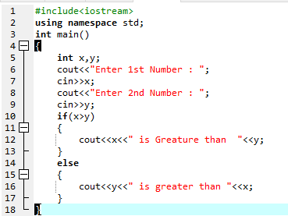

**OUTPUT:  
**

**Write a program of to swap the two values using templates**

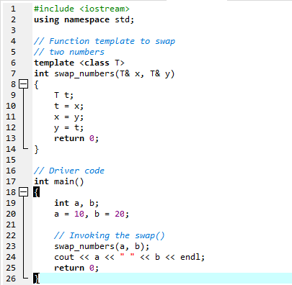

**OUTPUT:  
**

**Assume a class cricketer is declared. Declare a derived class batsman from**

**cricketer. Data member of batsman. Total runs, Average runs and best**

**performance. Member functions input data, calculate average runs, Display**

**data. (Single Inheritance)**

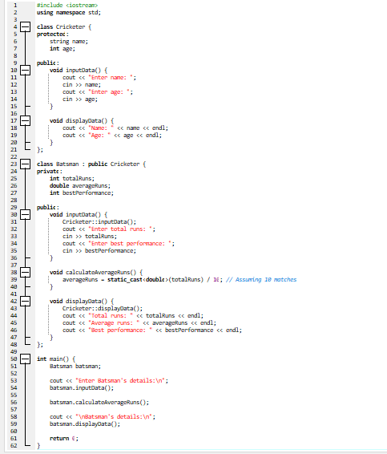

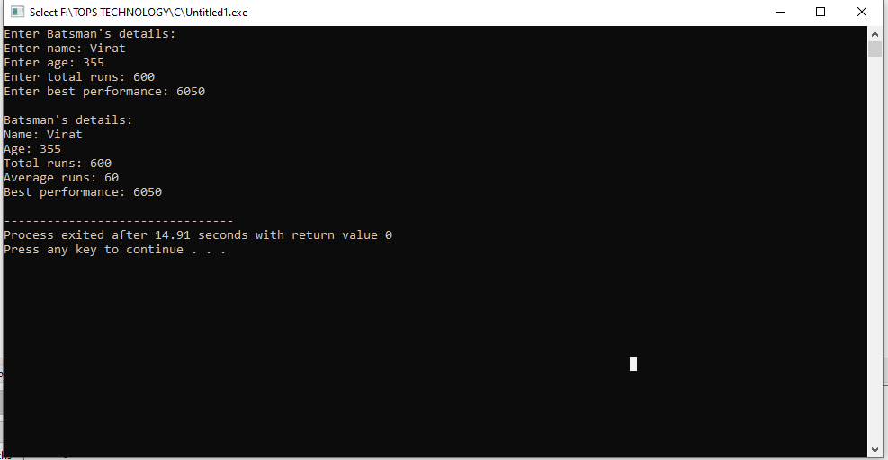

**Create a class person having members name and age. Derive a class student**

**having member percentage. Derive another class teacher having member**

**salary. Write necessary member function to initialize, read and write data.**

**Write also Main function (Multiple Inheritance)**

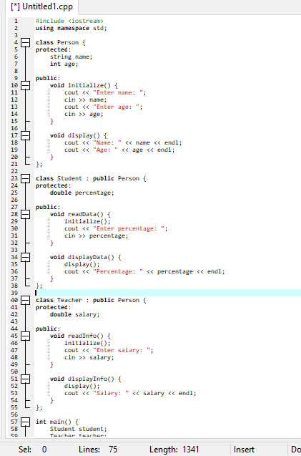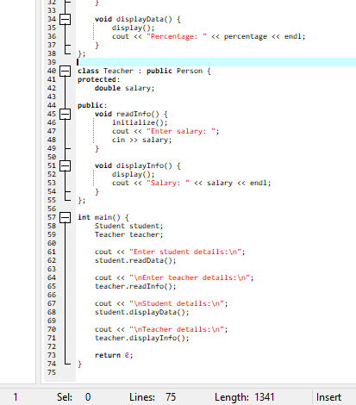

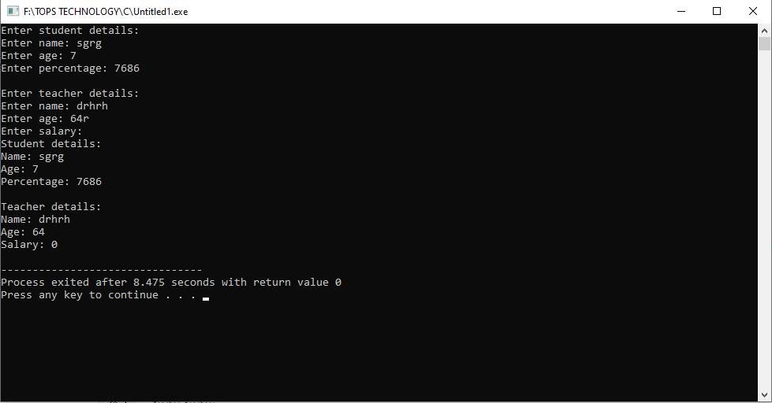

**Assume that the test results of a batch ofstudents are stored in three different**

**classes. Class Students are storing the roll number. Class Test stores the**

**marksobtained in two subjects and class result contains the total marks**

**obtained in the test. The class result can inherit the details of the marks**

**obtained in the test and roll number of students. (Multilevel Inheritance)**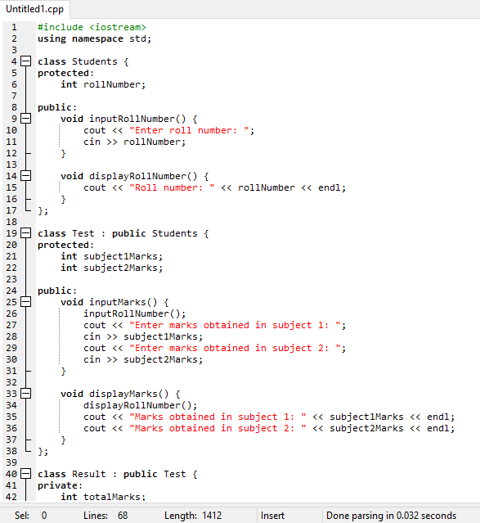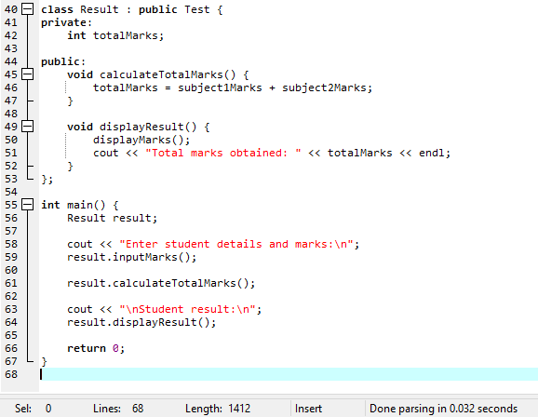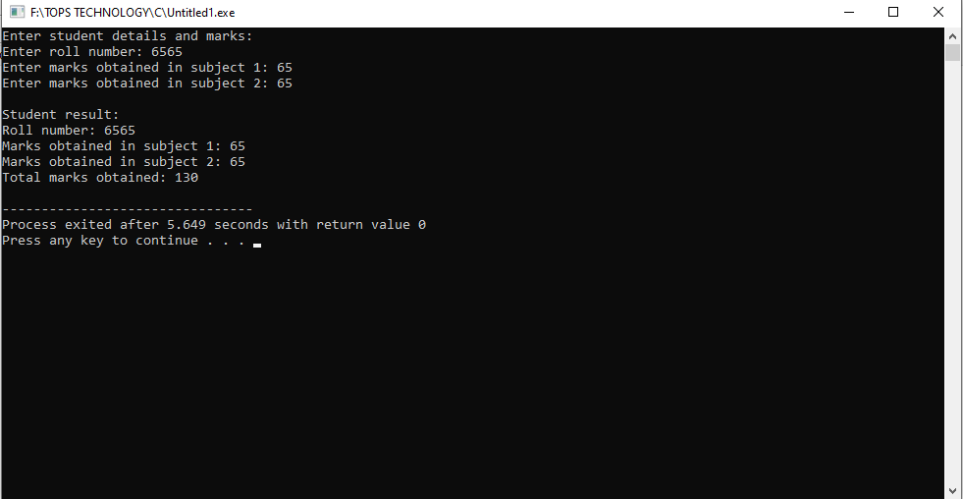

**Assume that the test results of a batch of students are stored in three different**

**classes. Class Students are storing the roll number. Class Test stores the**

**marks obtained in two subjects and class result contains the total marks**

**obtained in the test. The class result can inherit the details of the marks**

**obtained in the test and roll number of students. (Multilevel Inheritance)**

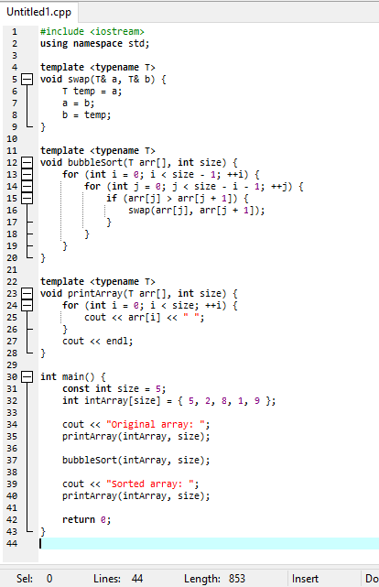

**Write a program of to sort the array using templates**

